Skill Week 12
Aim
To execute a large Linux pipeline with multiple processes, monitor system resources, detect failures, and analyze the performance of the pipeline.
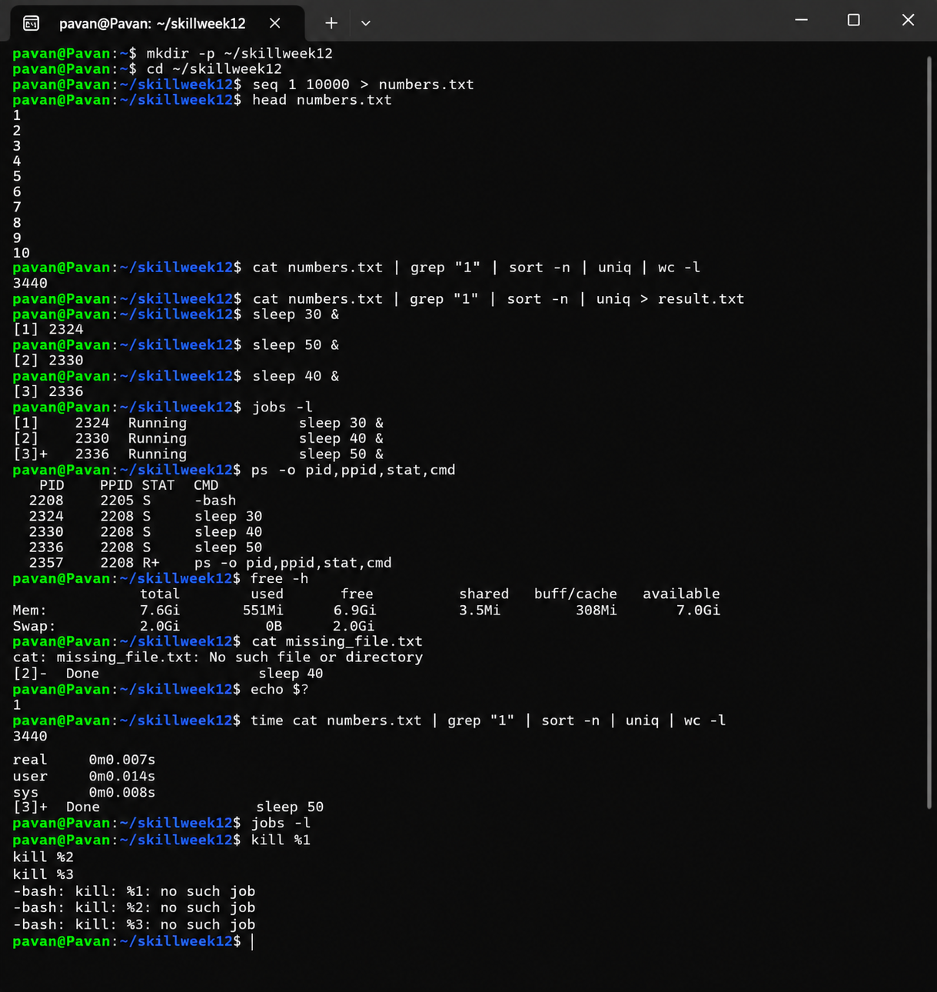
Observation
The Linux pipeline successfully processed the input data using multiple commands connected through pipes. Multiple background jobs were launched and monitored using jobs and ps. System resources were checked using free and uptime. A failed command was detected using its exit status, and pipeline execution time was measured using time.

Result
Large pipelines and multiple jobs were executed successfully. Process monitoring, failure detection, resource monitoring, and performance analysis were performed.

Aim
To document the architecture of a Linux program, create an execution flow, identify system calls, and record important design decisions.
Program:
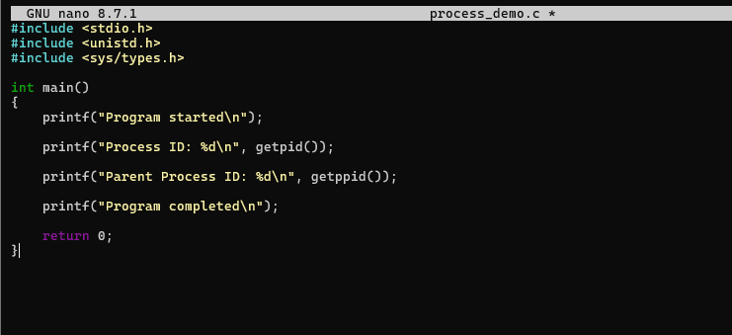
Output:
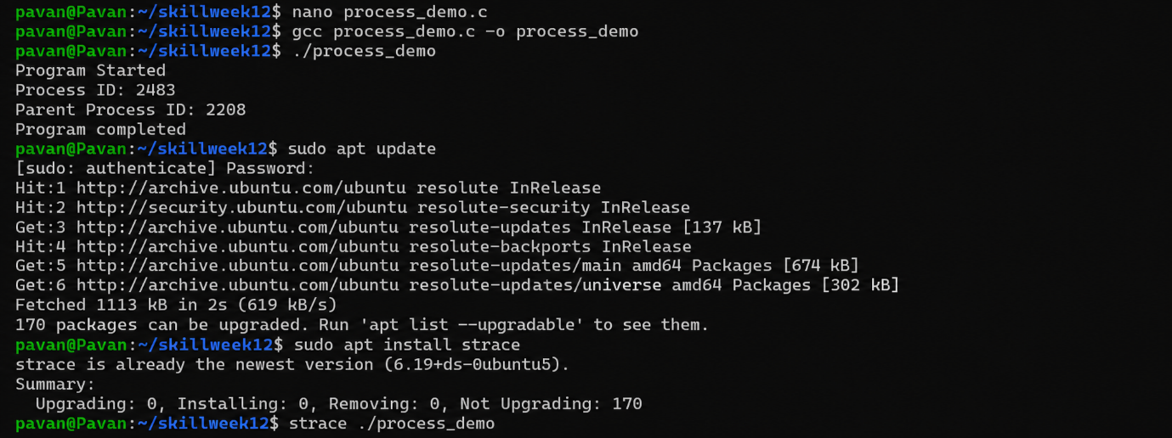
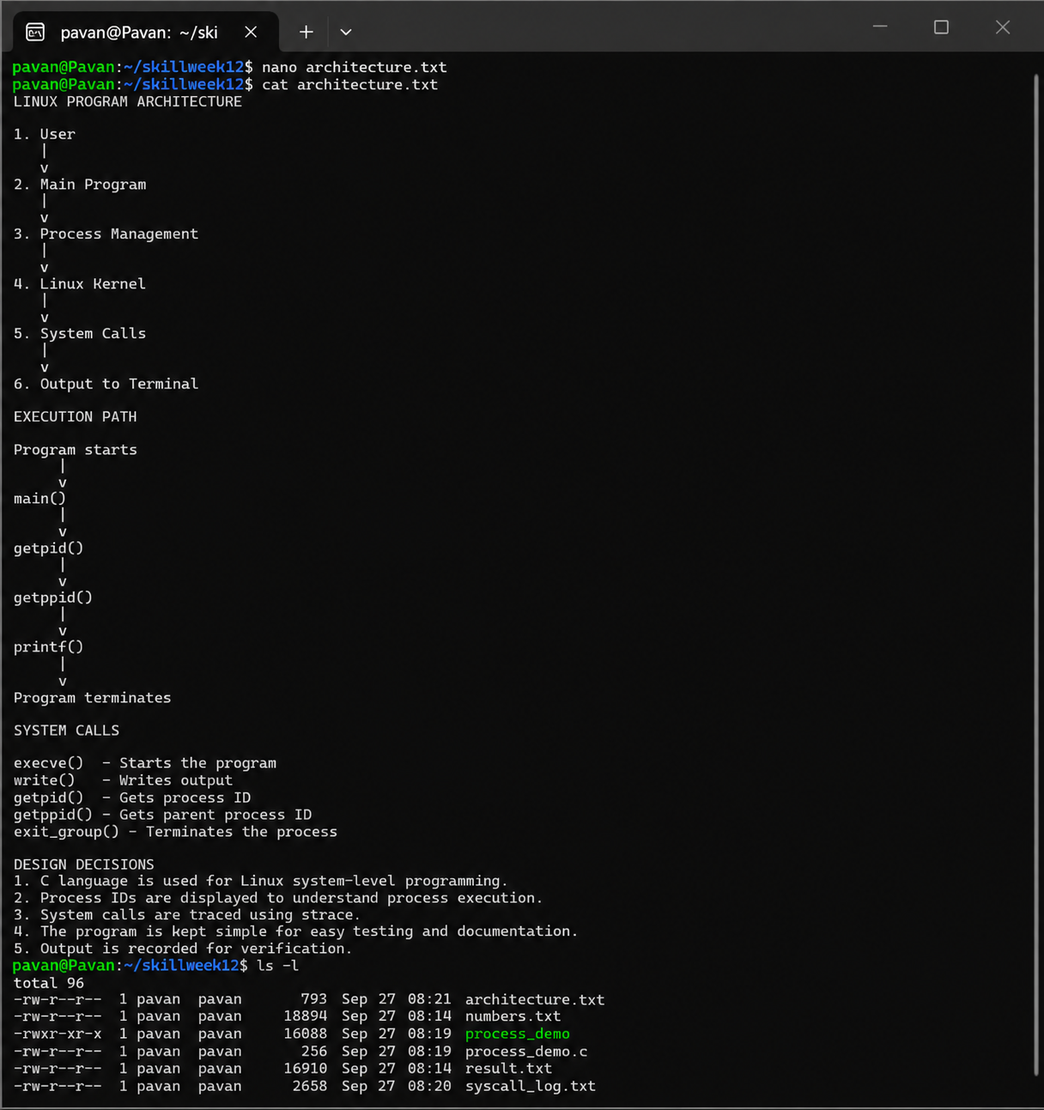
Observation
The program architecture and execution path were documented. The program displayed its process ID and parent process ID. System calls were traced using strace, and the system-call information was stored in syscall_log.txt.
Result
The Linux program architecture, execution path, system calls, and design decisions were successfully documented and reviewed.

Aim
To organize a Linux project source code, create a build script, prepare a README file, verify the project structure, and create a release tag
Program:
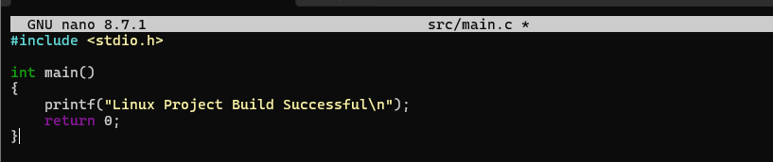
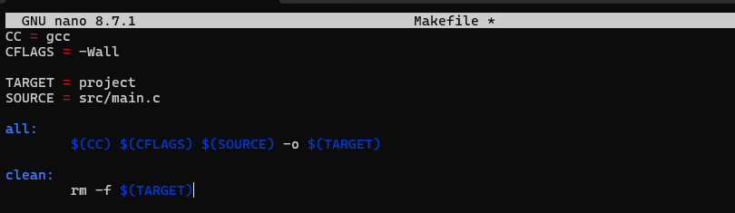
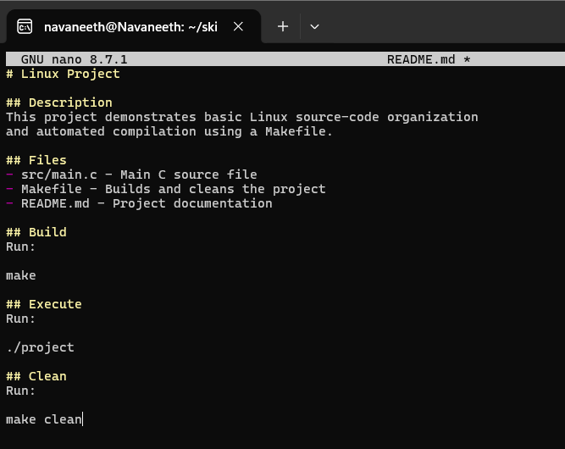

Output:
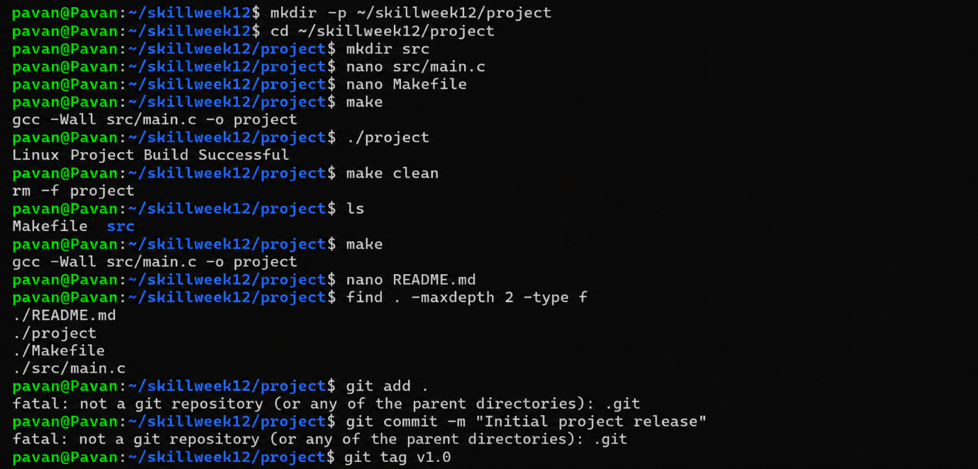

Observation
The project source code was organized into a separate src directory. A Makefile was created to automate compilation and cleaning. A README file documented the project. Git was initialized, the files were committed, and version tag v1.0 was created.
Result
The source code was organized, the build process was automated, documentation was added, the repository structure was verified, and the project was tagged as version 1.0.

Aim
To create and test different Linux demonstration scenarios, validate project features, demonstrate pipelines and signals, and perform a final project review.
Program:

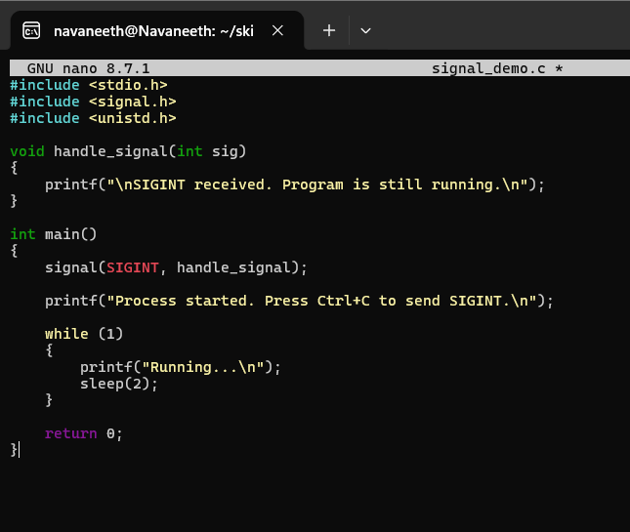
Output:
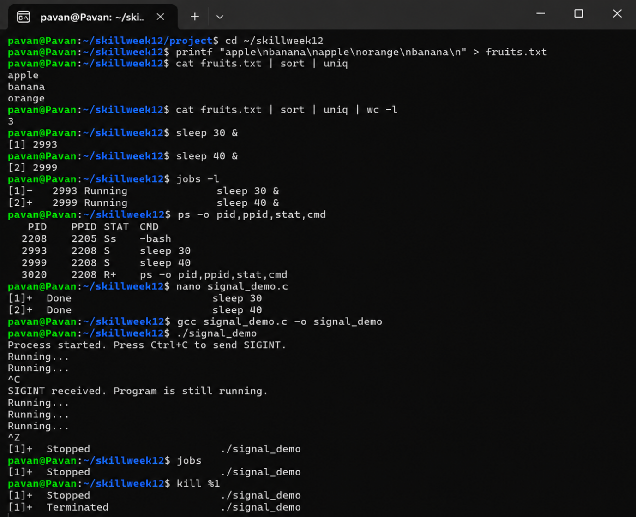
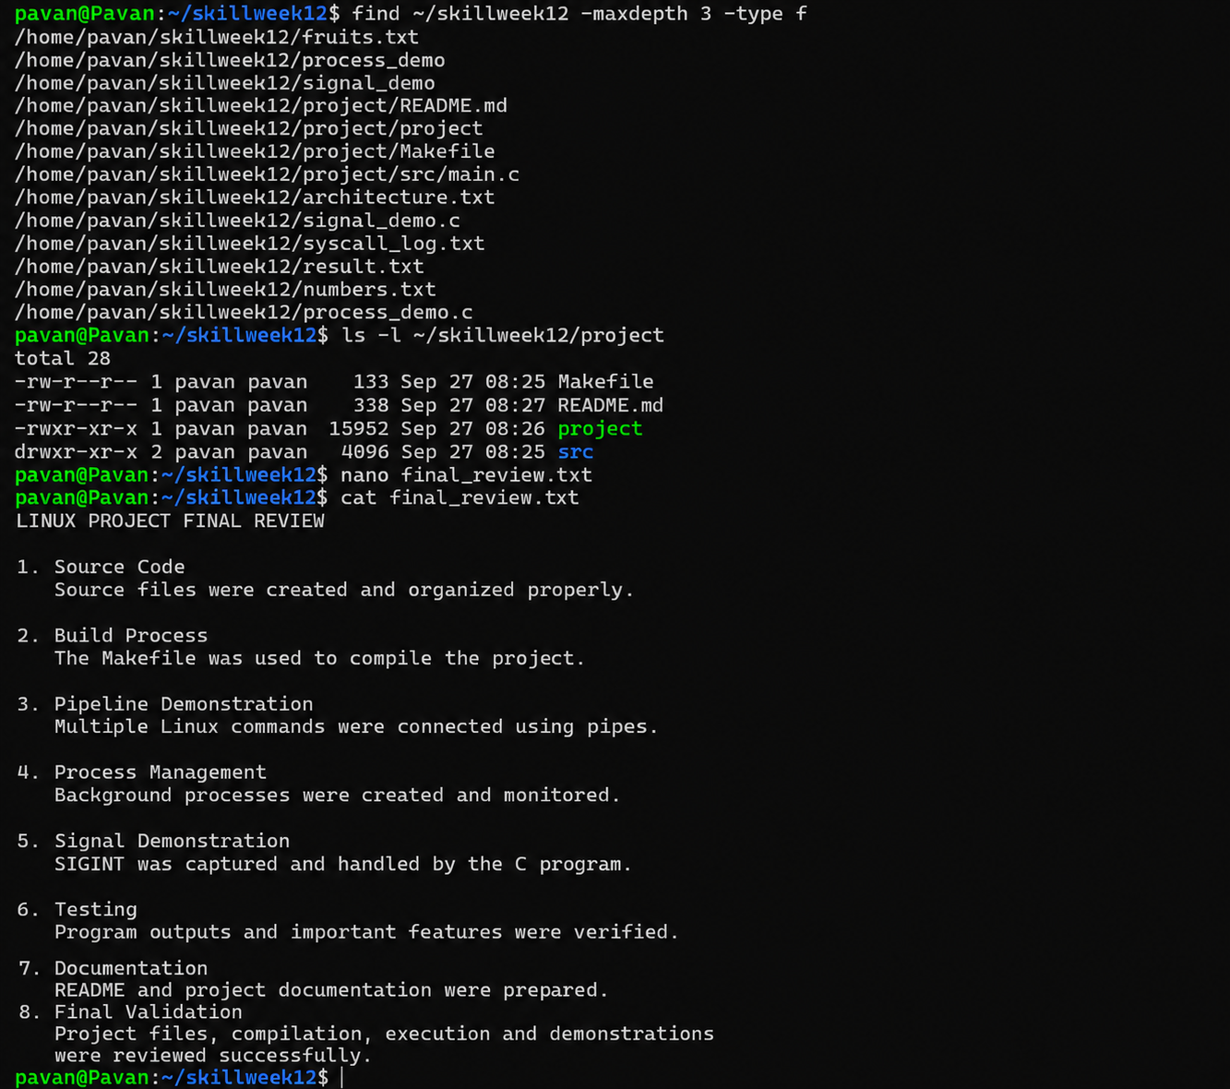
Observation
The project features were demonstrated and validated. Linux pipelines were executed, background processes were monitored, and signal handling was demonstrated using a C program. The project files and documentation were reviewed before the final presentation.
Result
Demo scenarios, pipeline execution, signal handling, feature validation, presentation rehearsal, and final project review were completed successfully.

